**Nazanine Matin: Encouraging Women Entrepreneurs to Take Charge**

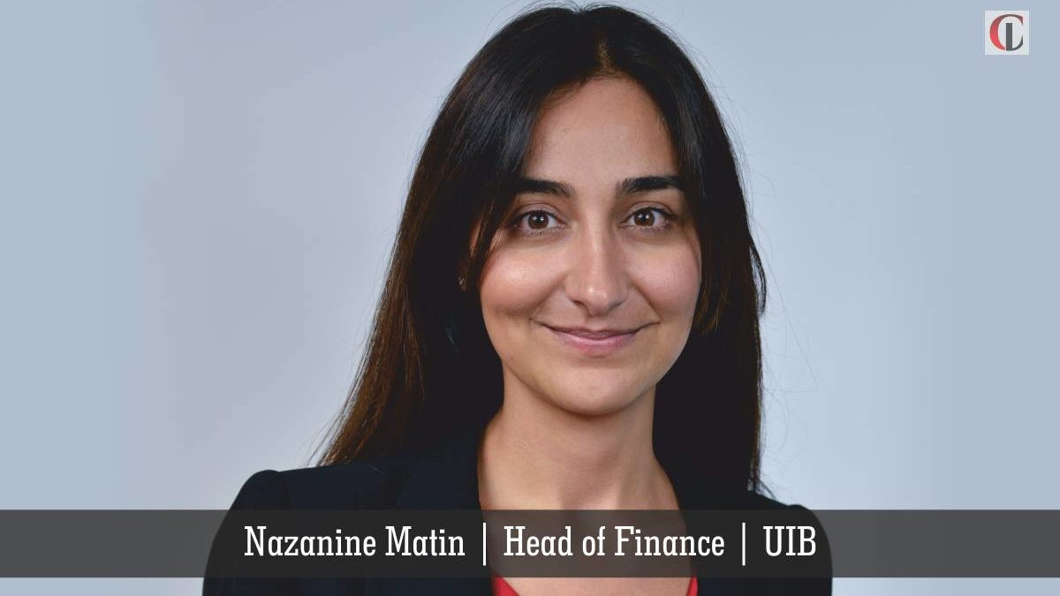

**The world is changing**. While long overdue, women are increasingly taking leadership roles in cutting-edge technology companies. With the courage to pursue her passions, the background to redefine global entrepreneurship and the ability to manage AI’s disruption, CIO Look brings to you the journey of avid entrepreneur, ***[Nazanine Matin](https://is.gd/hA1VMM" \t "_blank)***, the **Head of Finance** at **UIB Holdings Pte. Ltd.**

***Give a brief overview of your background and your role in the company.***

I earned my degree in Mechanical Engineering from U.C. Berkeley’s School of Engineering. I now have over 18 years of experience (and a few medical device patents) and have had roles in R&D, IT, Operations, Audit, Finance, and Cybersecurity in different industries.

I first stepped outside of the corporate world by working for and helping to set up startups owned by Demantra/Oracle, Mubadala, and GE. Most of my career, nine years, was spent with General Electric and I am a graduate of GE’s Corporate Audit Staff leadership program.

Today, I am the founder and curator of TEDxMonteCarlo and the Head of Finance of Singapore-based UIB Holdings Pte. Ltd. Both of these roles allow me to pursue my passion for inspiring people by sparking conversations on the topics that are changing our world.

Read more: [***https://is.gd/hA1VMM***](https://is.gd/hA1VMM)